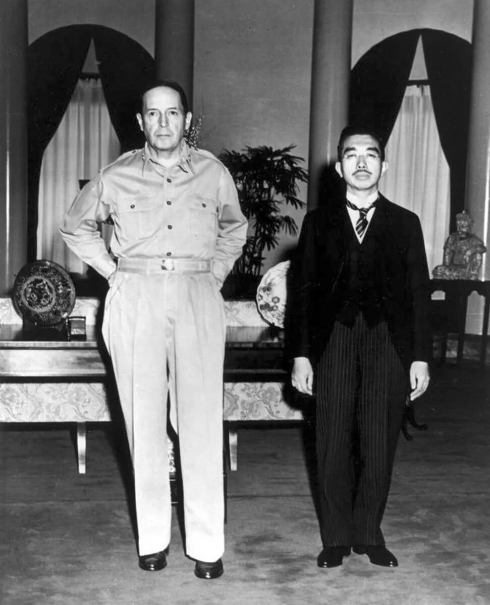

*Japanese Emperor Hirohito with SCAP Douglas MacArthur, September 1945 (File:Macarthur Hirohito.jpg, 2012)*

To what extent did the US occupation of Japan between 1945 and 1952 impact Japan's politics and economy up to 1991?

**International Baccalaureate History SL Internal Assessment**

**CANDIDATE NUMBER: lsh546**

**Word count: 2198**

### Table of Contents

Table of Contents 2

**Section 1: Identification and evaluation of sources 2**

1.1 Evaluation of “America’s Role in the Making Of Japan’s Economic Miracle” [Link] 3

1.2 Evaluation of “Japan Under Occupation, 1945-1952” [Link] 3

**Section 2: Investigation 5**

2.1 Introduction 5

2.2 US Occupation 6

2.3 Japanese Impact 7

2.4 Analysis 8

2.5 Conclusion 9

**Reflection 11**

**References 13**

## 

## Section 1: Identification and evaluation of sources

To what extent did the US occupation of Japan between 1945 and 1952 impact Japan's politics and economy up to 1991?

The first source that will be evaluated is (Beckley et al., 2018). It is relevant to the investigation as it examines the US Occupation's long-term impact on Japan's economy.

The second source that will be evaluated is (KURTULUS, 2016). It is relevant to the investigation as it provides a clear and thorough understanding of the US occupation period in Japan and captures the political impacts of the occupation period.

### 1.1 Evaluation of “*America’s Role in the Making Of Japan’s Economic Miracle*”

The origin of the source is an article published by the Journal of East Asian Studies in 2018. A value of the origin is that the Journal of East Asian Studies is one of the most prestigious peer-reviewed academic journals in Asian studies. Therefore, the information found within it is likely to be highly credible.

The purpose of the source is to review the role of the United States in Japan's economic growth, challenging the widespread view that Japan's economic success was only due to its domestic policies. A value of the purpose is that because it aims to challenge a popular view, it is a document with essential counter-arguments and counter-evidence necessary for balanced consideration of the topic.

The content of the source explains several aspects of the US impact on the Japanese economy. A value of the content is that it provides a thorough overview of the influences that shaped Japan's economic miracle. A limitation of the content is that it doesn’t offer information on the US during the US occupation. Therefore, certain sections of the content are irrelevant to the investigation.

The source’s values outweigh the limitations because it offers quantitative data and high-quality, objective information about Japan's economic prosperity resulting from the US Occupation.

### 

### 1.2 Evaluation of “*Japan Under Occupation, 1945-1952*”

The origin of the source is Oktay Kurtulsh. He studied at Chuo University, one of the most respected universities in Japan. The value of origin is that Oktay Krutulsh speaks Turkish, English, Japanese, and German, which means he can access diverse sources from diverse points of view and perspectives. The source has been peer-reviewed, which makes it more reliable for this IA. Therefore, this document is balanced and credible.

The purpose of the source is to reexamine the US occupation and understand the essentials of the US occupation between 1945 and 1952. A value of the purpose is his intention to provide a clear and analytical point of view on the occupation's policies, especially on the political and economic transformations within occupied Japan.

The content of the source reexamines the US occupation and understands its essentials. A value of the content is that it shows different interpretations (orthodox and revisionist) from traditional historians to improve our understanding of the US occupation of Japan. A limitation of the content is its focus on the period of occupation and the reforms that immediately followed, which did not extend to the long-term impact on Japan's political and economic conditions until 1991.

The source’s values outweigh the limitations because it shows different interpretations from traditional historians, thus giving access to different perspectives about the US occupation of Japan.

## Section 2: Investigation

### 2.1 Introduction

The role of the US versus Japan in the development of Japan’s economic miracle is a subject of debate. This discussion extends to the impact of the US occupation of Japan from 1945 to 1952 on Japan’s politics and economy up to the end of the Cold War in 1991. In some research, such as (Crawford, 1998), Japan's pre-war economy, economic planning, and domestic investment were the main factors of their economic miracle. However, there is also much research, such as the work by Michael Beckley, Yusaku Horiuchi, and Jennifer M. Miller (Beckley et al., 2018), that declares that Japan’s close alliance with the US played a bigger role in Japan's impressive economic growth. Therefore, this paper’s research question is: ”To what extent did the US occupation of Japan between 1945 and 1952 impact Japan's politics and economy up to 1991?”.

### 2.2 US Occupation

In September 1945, General Douglas MacArthur became the Supreme Commander of the Allied Powers (SCAP) following the Potsdam Declaration, which called for Japan's unconditional surrender (Office of the Historian, n.d.). This marked a significant transformation of the Japanese government and society. SCAP’s initial focus on demilitarization and democratization saw the introduction of a new constitution that drastically changed Japan's political structure, downgrading the emperor's status to a symbolic status with no political power, placing more power in the parliamentary system while completely disarming and demilitarizing Japan.

A key economic reform was the dissolution of the Zaibatsu, large families-controlled vertical conglomerates that had dominated the economy since the 19th century during the Meiji period (KURTULUS, 2016). This policy aimed to dissolve monopolies and encourage a competitive and diversified economic landscape. The efforts towards economic democratization laid the foundation for a more balanced industrial sector.

SCAP also integrated Japan into the global economy by promoting Japanese exports, notably to the US, which absorbed over 30% of Japan’s exports. This is a significant aspect of the American occupation, ensuring a market for Japanese manufactured goods (Turner et al., 2022).

According to Andrew J Grad, the land reform program is among the most significant reforms during the US occupation. In 1947, almost half the population was part of the farm population. A small number of landlords owned much of Japan's land. SCAP’s land reform distributed agricultural land to local farmers. This significantly improved agrarian productivity and rural incomes (Grad, 1948).

The San Francisco Peace Treaty came into effect on 28 April 1952, with the US maintaining its bases in Japan and promising a bilateral security pact to Japan. As a result, all the military budgets went into the economy (Office of the Historian, n.d.).

### 

### 2.3 Japanese Impact

While the US occupation of Japan from 1945 to 1952 significantly impacted the country's recovery, several intrinsic Japanese factors were also essential in shaping Japan's economic miracle. These factors reflect Japan's unique position as a "producer economic state," a concept highlighted by Robert J. Crawford (Crawford, 1998). This model has benefited from two essential elements: large companies and a well-educated workforce.

The state robustly supported Japanese capitalism, with the government actively encouraging industrial growth. The Japanese government provided substantial backing to critical industries, a strategy already in place before WW2. For instance, industries such as aluminum and shipbuilding received support, allowing them to emerge as global leaders before the war (Bhuiyan, 2019). After the war, the Ministry of International Trade and Industry became central to Japan's economic reform efforts. According to (Yosano & Makino, 1999) and (Mikio Sumiya, 2000), MITI's policies were crucial in facilitating Japan's rapid recovery, as they enabled the efficient allocation of resources to high-growth sectors (Bhuiyan, 2019).

The keiretsu system also played a significant role in Japan's economic miracle. Keiretsu, literally translated as “grouping of enterprises”, are large, interconnected companies that work closely together, often centered around a central bank that replaced the Zaibatsu system dissolved during the Japanese occupation (Miwa & J. Mark Ramseyer, 2010). Few keiretsu became world leaders in the global economy, such as Nissan, Toyota, Mitsubishi and Toshiba. This structure ensured financial stability and fostered industry innovation and competitiveness (Miwa & J. Mark Ramseyer, 2010).

Following Crawford's idea that Japan is an excellent example of a “producer economic state”, the Japanese workforce was also a critical factor in its economic miracle. With a high birth rate and excellent schools, employers from the 1950s until the late 1960s found a large, well-educated young workforce (Bhuiyan, 2019). Furthermore, the patriotism and strong nationalism of the Japanese population were positive elements (Bhuiyan, 2019). The desire to surpass the previous level of development led the entire working population to surpass itself. This is an intrinsic element of Japanese culture.

Japanese defeat meant devaluing the military, but the chase for economic power didn’t change (Beckley et al., 2018).

### 2.4 Analysis

The Korean War (1950-1953) was significant during the American fight against communism in Asia. American purchases of goods and services during the Korean War significantly boosted Japan's economy (Bhuiyan, 2019). Some studies argue that the Korean Wan kick-started Japan’s growth via military procurement orders (Beckley et al., 2018). This economic boost, facilitated by the US occupation, directly resulted from Japan's strategic alignment with American interests during the Cold War (Turner et al., 2022).

By 1956, real per capita GDP had overtaken the 1940 level, and by 1970, Japan boasted the third-largest economy and ranked among the most developed countries in the world (Turner et al., 2022). The US occupation's policies facilitated the reintegration of these individuals into the workforce, further accelerating Japan’s economic recovery (Nishizaki, 2020).

According to Salvatore Babones, Japan is the only large country with a diversified economy that has risen from a below-average level of development to the upper tier of the world economy. This affirmation shows that the Japanese economic miracle didn’t happen because of one factor. Some reforms from the US occupation brought about a competitive economy but couldn’t have been as successful without the Japanese workforce. Goods produced by the industries always found buyers thanks to the great position of Japan introduced by the US in the global and US markets. A stable political situation was also essential in keeping the country on the same political path during the miracle years.

According to Michael Beckley, Yusaku Horiuchi, and Jennifer M. Miller, Japan might have developed without the US, but it is unlikely to have developed as quickly or thoroughly. This statement can be supported by Japan's synthetic growth without the security pact, which was much smaller than its real growth with the security pact.

Other studies, such as (Beckley et al., 2018), compared Japanese synthetic growth without the security pact with real Japanese growth. The results suggest that while Japan’s average annual growth rate was 9.3 percent from 1958 to 1968, synthetic Japan only grew at 3.6 percent per year (Beckley et al., 2018; Turner et al., 2022). This clearly shows that the Japanese economic miracle is due, to a large extent, to the US occupation. Other factors also had a strong positive impact on the Japanese economy and politics outside the US occupation. Firstly, the US occupation had a substantial short-term impact on Japan's political landscape, transforming it into a true democracy. The US occupation also put the foundations of the Japanese economy back in place. It established a powerful alliance with Japan that has had a significant long-term impact on its economic miracle, as shown in the study (Beckley et al., 2018).

### 2.5 Conclusion

The US occupation of Japan significantly and positively impacted Japan's economy and politics up to 1991, playing a crucial role in the country's recovery. To a large extent, the US occupation established the foundations for Japan's economic miracle through reforms like the dissolution of the Zaibatsu, land redistribution, and integration into the global economy. Establishing a security pact with the US ensured Japan's strategic position during the Cold War, freeing up the budget initially intended for the army and providing access to American markets.

Beyond Japan's internal strategies and cultural factors, such as a high savings rate, a well-educated, low-cost workforce, and intense nationalism, the occupation fundamentally transformed Japan into a modern democratic state. The reforms of the US occupation and the security pact enabled Japan to grow at an unprecedented rate, far surpassing the growth rates of a hypothetical, non-occupied Japan. Japan's growth from a war-ravaged nation to a leading global economy shows the global impact of the US occupation, demonstrating that the economic miracle resulted from a mix of American influence and Japan's internal resilience. Thus, the US occupation of Japan between 1945 and 1952 had a positive, to a large extent, impact on Japan's politics and economy up to 1991.

## 

## Reflection

A historical method I used was comparing the American policies and politics during the US occupation of Japan between 1945 and 1952 with the Japanese effect during the pre-war and post-war periods. This approach is highly valuable for understanding the impact of the US occupation on the Japanese domestic strategies in shaping Japan's politics and economic miracle up to 1991. However, I quickly realized the limitations of this approach, as I am limited to comparing the Japanese impact with the American impact when many other factors impacted post-war Japanese economics and politics.

For example, American policies such as the dissolution of the Zaibatsu, land reforms, and powering up the parliament impacted Japan's economy and politics. Nevertheless, Japanese initiatives like strategic economic planning and the keiretsu model also played a crucial role in shaping their economic miracle. Thus, I needed to consult a broader range of sources to properly understand these impacts without overlooking essential factors. For instance, (Beckley et al., 2018) provided a detailed analysis of US reforms and their role in Japan’s economic miracle but lacked insights into Japan's social changes. To address this limitation, I utilized secondary sources like (KURTULUS, 2016), which gave access to in-depth information on the political and social reforms of the US occupation or even other information that I didn't necessarily include in my IA but which enabled a more profound understanding of this period.

Furthermore, I learned that the historical comparison method is limited in some aspects. My analysis could become more thorough and nuanced by combining a wide range of secondary and primary sources and perspectives, leading to more explicit conclusions. Comparing American and Japanese policies allowed me to understand precisely the American contributions to Japan's economic miracle.

Writing this IA highlighted how comparing American and Japanese policies clarified each side's contribution to Japan's post-war economic miracle. I learned that this historical method requires careful source selection to avoid overgeneralization and simplification. However, by addressing these challenges, I can thoroughly evaluate the relative significance of American and Japanese strategies in shaping Japan's post-war economy and politics.

## References

Beckley, M., Horiuchi, Y., & Miller, J. M. (2018). AMERICA’S ROLE IN THE MAKING OF JAPAN’S ECONOMIC MIRACLE. Journal of East Asian Studies, 18(1), 1–21. https://doi.org/10.1017/jea.2017.24

Bhuiyan, Z. A. (2019, June). The miracle of Japanese Economy after the Second World War (WW2). ResearchGate. https://www.researchgate.net/publication/333561460_The_miracle_of_Japanese_Economy_after_the_Second_World_War_WW2

Crawford, R. J. (1998, January). Reinterpreting the Japanese Economic Miracle. Harvard Business Review. https://hbr.org/1998/01/reinterpreting-the-japanese-economic-miracle

File:Macarthur hirohito.jpg. (2012, May 12). Wikipedia. https://en.wikipedia.org/wiki/File:Macarthur_hirohito.jpg

Grad, A. J. (1948). Land Reform in Japan. Pacific Affairs, 21(2), 115. https://doi.org/10.2307/2752510

Grimes, W. W. (1999). JAPAN AND GLOBALIZATION: FROM OPPORTUNITY TO CONSTRAINT. Asian Perspective, 23(4), 167–198. https://www.jstor.org/stable/42704238

HOME. (n.d.). Political Science. https://www.michaelbeckley.org/

Jennifer M. Miller. (2013, July 10). Faculty Directory. https://faculty-directory.dartmouth.edu/jennifer-m-miller

Journal of East Asian Studies. (2024, January 1). Wikipedia. https://en.wikipedia.org/wiki/Journal_of_East_Asian_Studies

Journal of East Asian Studies | Cambridge Core. (2019). Cambridge Core. https://www.cambridge.org/core/journals/journal-of-east-asian-studies

KURTULUS, O. (2016). Japan Under Occupation, 1945-1952.

Mikio Sumiya. (2000). A History of Japanese Trade and Industry Policy. OUP Oxford.

Miwa, Y., & J. Mark Ramseyer. (2010). The Fable of the Keiretsu. University of Chicago Press.

Nishizaki, S. (2020). After Empire Comes Home: Economic Experiences of Japanese Civilian Repatriates, 1945–56. Australian Economic History Review, 60(2), 259–267. https://doi.org/10.1111/aehr.12199

OECD. (1972). OECD Economic Surveys: Japan 1972. In OECD iLibrary. Organisation for Economic Co-operation and Development. https://www.oecd-ilibrary.org/economics/oecd-economic-surveys-japan-1972_eco_surveys-jpn-1972-en

Office of the Historian. (n.d.). Milestones: 1945–1952 - Office of the Historian. History.state.gov. https://history.state.gov/milestones/1945-1952/japan-reconstruction#:~:text=After%20the%20defeat%20of%20Japan

Oktay KURTULUS (Turkey). (n.d.). https://www.grips.ac.jp/cms/wp-content/uploads/2018/02/DOC17011_Kurtulus-Oktay.pdf

Turner, O., Nymalm, N., & Aslam, W. (2022). The Routledge Handbook of US Foreign Policy in the Indo-Pacific. Taylor & Francis.

Yosano, K., & Makino, S. (1999). MITI Minister Kaoru Yosano on Reviving Japan’s Competitive Advantage. The Academy of Management Executive, 13(4), 9–11.

Yusaku Horiuchi – Yusaku Horiuchi’s Homepage. (n.d.). Yusaku Horiuchi. Retrieved May 6, 2024, from https://horiuchi.org/